The customer is an online store with a warehouse and a delivery service. The architectural style is shown in Figure 1.

Figure 1 – Current architecture

The current architectural style is a set of monolithic applications that has a number of disadvantages and problem areas that are inherent in monolithic systems and that can arise as a project grows:

* Difficult continuous deployment and support. Since there are several applications that use the same logic (for example web and mobile apps for purchasing), with the slightest change in one of the modules, we will have to completely redeploy both applications;
* Difficult to scale. It can be difficult to scale when different modules have conflicting resource requirements;
* Slow start-up time. As the project grows, the application launch time may decrease;
* etc.

Customer has plans to enter the markets in several other countries. This means that the client base will grow, and with it the need for features will grow too. It is also necessary to maintain the current functionality in working order. Also, with the entry into new markets, it will become necessary to deploy a new infrastructure, which will be problematic and costly with the current architecture.

To select a new architectural style, more input data is needed, such as:

**What are the sales forecasts in the new country?** From this question, we should understand whether we want to invest large resources (developers, testers, cloud rent) from the start or not.

It is logical to assume that we would like to get a better result with less investment. Ultimately, we would like to have an architecture with the following advantages:

* Easy to scale;
* Testable;
* Ease of understanding = simple support;
* Smaller and faster deployments.

To meet all these requirements, I would choose a service-oriented style of architecture, but with the possibility of switching to a hybrid style. We can switch to a hybrid style gradually, depending on the new requirements and depending on project growth. The proposed architectural style is shown in Figure 2.

Figure 2 – Possible architecture

Enterprise Service Bus (ESB) is an element of the IT landscape for integrating disparate information systems into a single software package with centralized management of information transfer.  
Typically, an ESB includes the following components:

* a set of connectors for connecting to various systems in order to receive and send data;
* message queue (Message Queue, MQ) for organizing intermediate storage of messages during their delivery;
* a platform that connects connectors to a queue, and also organizes asynchronous transmission of information between sources and receivers with guaranteed message delivery and the possibility of their transformation.

Enterprise Service Bus requirements:

* support for different data schemes (events);
* ensuring at least once message delivery;
* speed of updates;
* the ability to reuse events.

Given these requirements, the implementation of the ESB can be as follows (Figure 3).

Figure 3 – ESB architecture

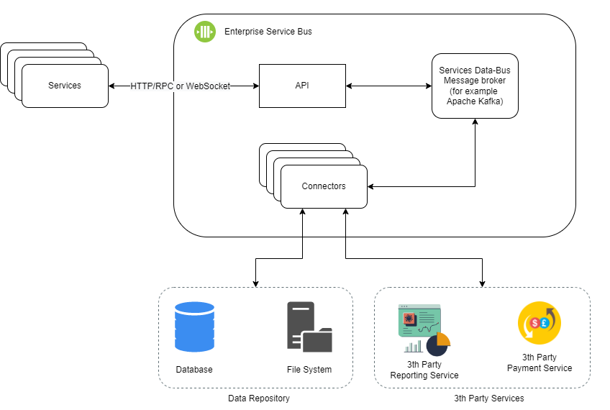

API Gateways are used as an aggregation layer for services. The use of API Gateway is an important factor for component reuse and cost optimization. API Gateway takes care of common API management tasks such as security, caching, throttling, and monitoring. While its primary purpose is to build an abstract layer on top of services.

The main advantages of this architecture:

* Reusable services. Helps to avoid copy/paste, making future support easier and cheaper;
* Possibility of parallel development. A separate team can develop a separate service;
* Simplified CI/CD pipeline. Each service can be delivered separately. There is no need to redeploy all services and apps if the changes were made in only one module;
* Scalable. If any service getting many users, then it can be easily scalable by attaching more servers.

The main advantages of this architecture:

* The ESB could become a single point of failure which impacts the entire system. Since every service is communicating through the ESB, if one of the services slows down, it could clog up the ESB with requests for that service.